What is Light in Physics?
Light is electromagnetic radiation that can be detected by the human eye. Electromagnetic radiation occurs over an extremely wide range of wavelengths, from gamma rays with wavelengths less than about 1 × 10−11 metres to radio waves measured in meters.
Quantum theory describes light as consisting of discrete packets of energy, called photons. However, neither a classical wave model nor a classical particle model correctly describes light; light has a dual nature that is revealed only in quantum mechanics. This surprising wave-particle duality is shared by all of the primary constituents of nature (e.g., electrons have both particle-like and wavelike aspects).
Light as a Wave:
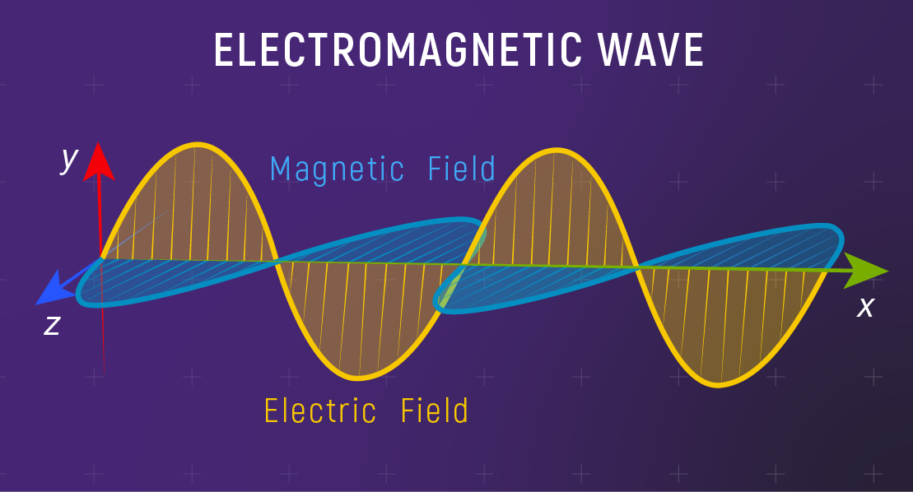
Light as a particle:
Einstein believed light is a particle (photon) and the flow of photons is a wave. The main point of Einstein's light quantum theory is that light's energy is related to its oscillation frequency.
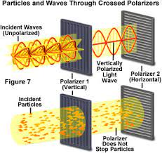
What is the Speed of Light?
The speed of light in a vacuum is a fundamental physical constant, and the currently accepted value is 299,792,458 meters per second, or about 186,282 miles per second.
What is a rainbow?
A rainbow is formed when sunlight is refracted by spherical water droplets in the atmosphere; two refractions and one reflection, combined with the chromatic dispersion of water, produce the primary arcs of color.
Photo: A tomato reflects the red part of sunlight and absorbs all the other colors.
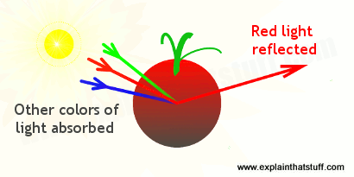
Light Spectrum:
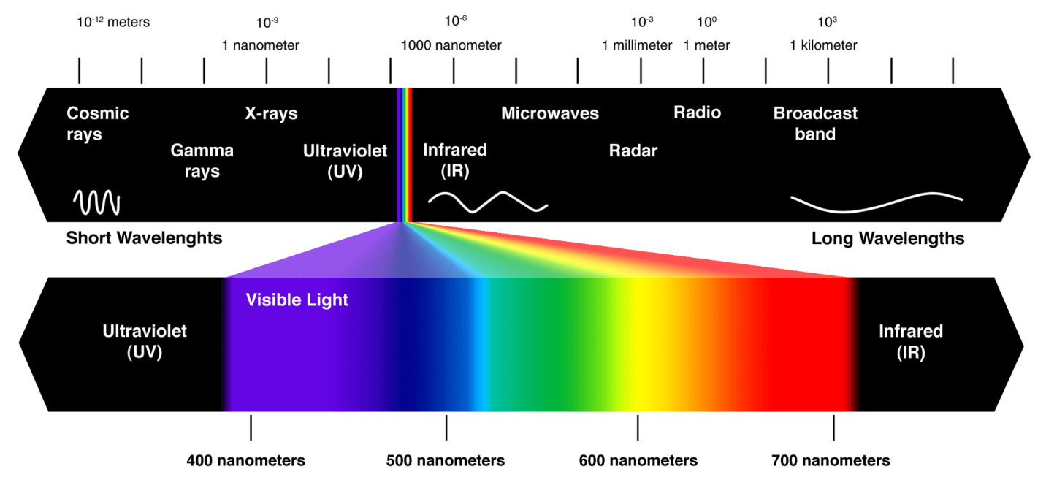
Key definitions to measure light (the quality of being luminous; emitting or reflecting light. "luminosity is measured relative to that of our sun"):
- Photon – a particle representing a quantum of light or other electromagnetic radiation. A photon carries energy proportional to the radiation frequency but has zero rest mass.
  - 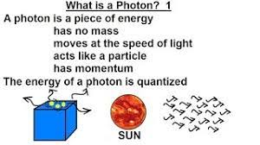
- Steradian – the SI unit of solid angle, equal to the angle at the center of a sphere subtended by a part of the surface equal in area to the square of the radius.
  - 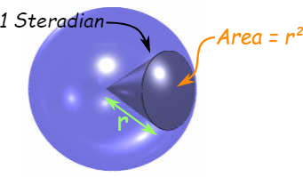
- Luminous Flux – (in lumens) is a measure of the total amount of light a light source puts out.
- Luminous Intensity – (in candela) the quantity of visible light that is emitted in unit time per unit solid angle.
- Lumens – the SI unit of luminous flux, equal to the amount of light emitted per second in a unit solid angle of one steradian from a uniform source of one candela.
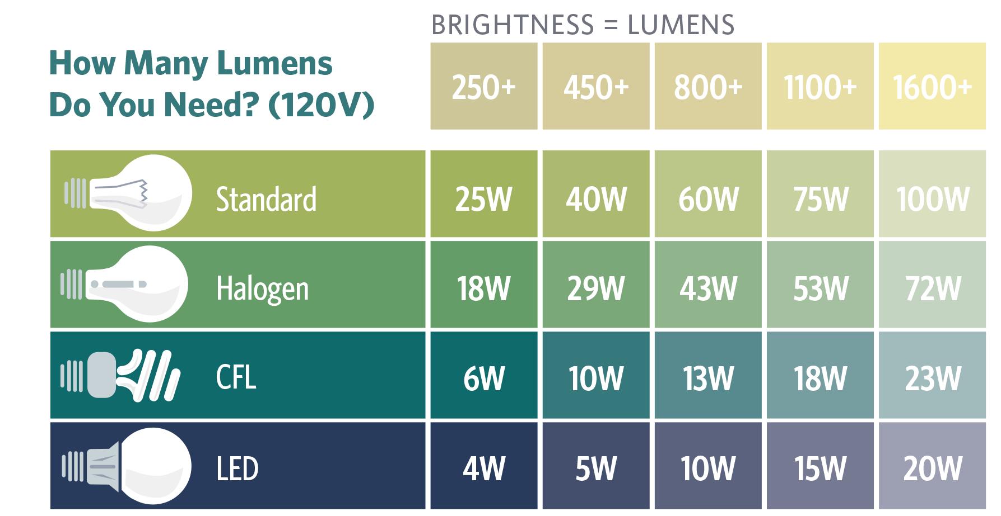
- Candela – the SI unit of luminous intensity. One candela is the luminous intensity, in a given direction, of a source that emits monochromatic radiation of frequency 540 × 1012 Hz and that has a radiant intensity in that direction of 1/683 watt per steradian.
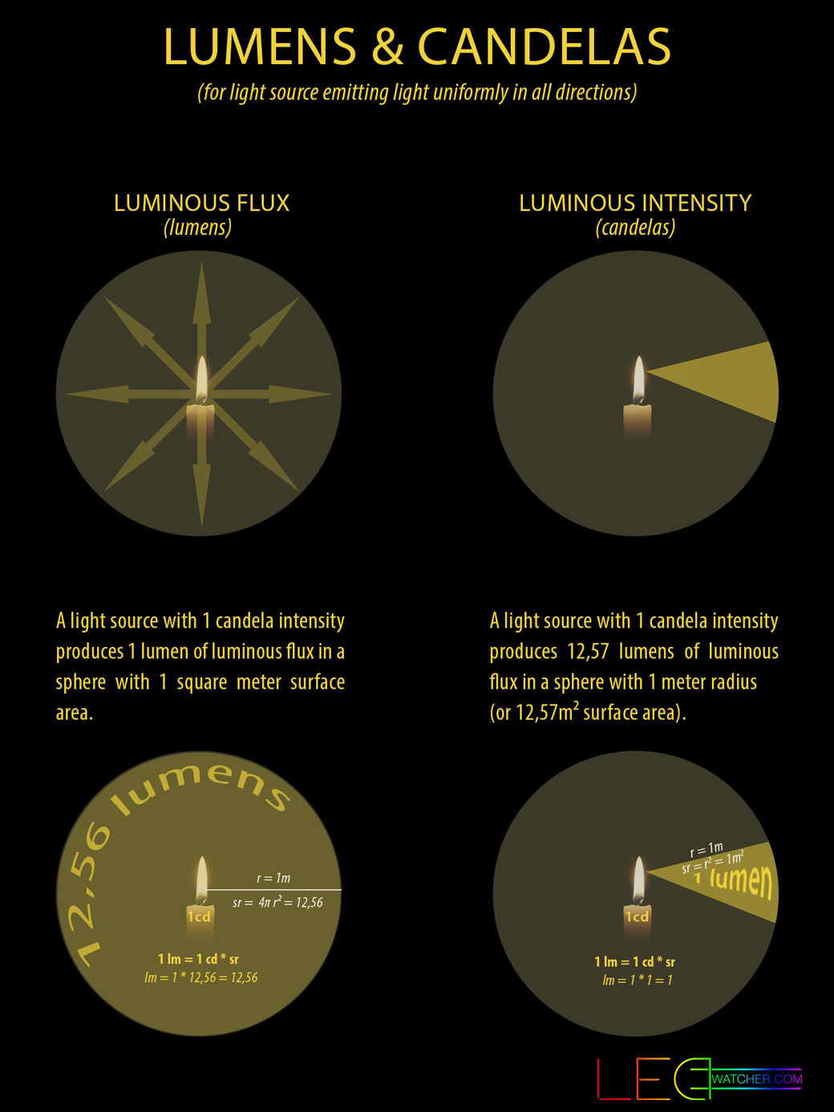
- Lux – the SI unit of illuminance, equal to one lumen per square meter.
  - A measurement of 1 lux is equal to the illumination of a one meter square surface that is one meter away from a single candle.
  - 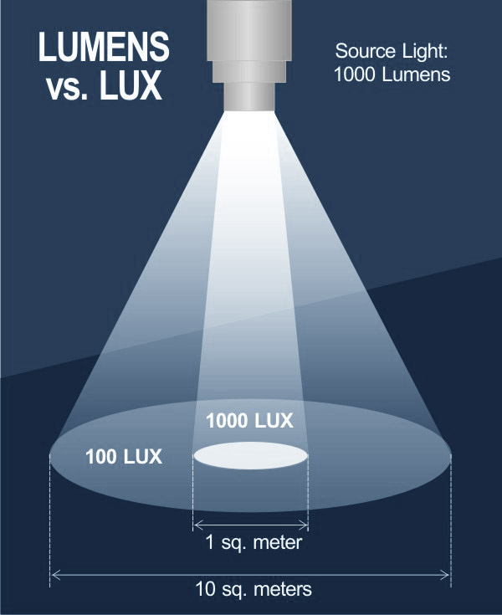
- How many Lux is full Sun?
- Intensity in different conditions
Illuminance | Example
120,000 lux | Brightest sunlight
111,000 lux | Bright sunlight
109,870 lux | AM 1.5 global solar spectrum sunlight (= 1,000.4 W/m²)
20,000 lux | Shade illuminated by entire clear blue sky, midday

Lumen to Lux calculator: https://www.bannerengineering.com/us/en/company/expert-insights/lux-lumens-calculator.html
When we make light by heating things, that's called incandescence. So old-style lamps are sometimes called incandescent lamps.
You can also get atoms excited in other ways. Energy-saving light bulbs that use fluorescence are more energy efficient because they make atoms crash about and collide, making lots of light without making heat. In effect, they make cold light rather than the hot light produced by older-style, energy-wasting bulbs. Creatures like fireflies make their light through a chemical process using a substance called luciferin. The broad name for the various different ways of making light by exciting the atoms inside things is luminescence.
Photo: A glow stick makes "cold light" using luminescence. Photo by Demetrius Kennon courtesy of US Navy.
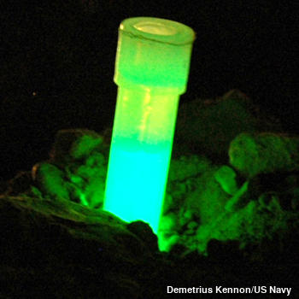
Color Temperature: Color temperature, is defined as “the temperature of an ideal black-body radiator that radiates light of a color comparable to that of the light source.” (Wikipedia) A blackbody is an object that absorbs all radiation, which includes visible light, infrared light, ultraviolet light, etc.
In laymens terms, color temperature is used as a method of describing the warmth or coolness color characteristics of a light source.
Color temperature, in practice, is only useful for light sources that fall in a color spectrum of reddish/orange (yellow based) to white (blue based). This is because this spectrum corresponds closely to the radiation of a black body, whereas purples and greens do not.
This range of color can be seen when heating metal, which initially emits red light that graduates from orange to yellow, then from white to blue.
The spectrum of color temperatures is assigned numerical values, measured in degrees of Kelvin. And these values are used to describe the color emitted from fixtures when working with lighting.
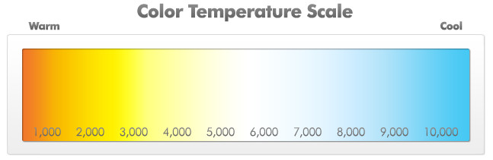
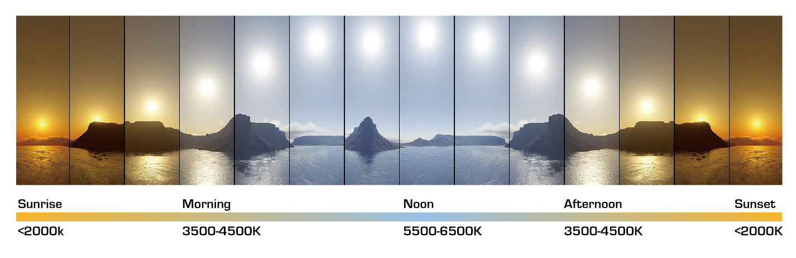
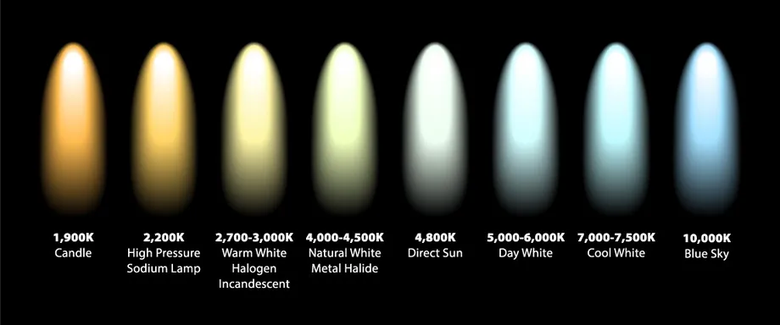
Relationship between Light and Power: Light can also be associated with energy, and there also is a simple relationship of energy and wavelength. The longer the wavelength, the less the energy, and vice versa. Visible light is less energetic than, say, ultraviolet light or X-rays, and more energetic than infrared radiation or radio waves.
Light is a form of energy, which is why photovoltaic cells can harness the primary energy flow of sunlight to make electricity.
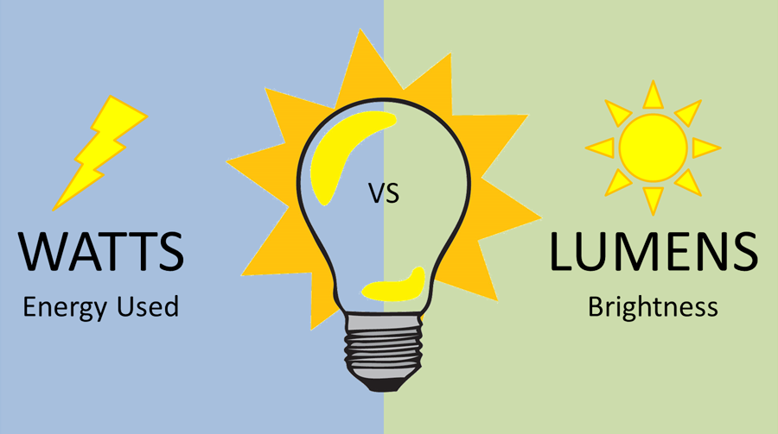
Laser ≡ Light Amplification by Stimulated Emission of Radiation - Lasers produce a narrow beam of light in which all of the light waves have very similar wavelengths. The laser's light waves travel together with their peaks all lined up, or in phase. This is why laser beams are very narrow, very bright, and can be focused into a very tiny spot.
Light-Emitting Diode (LED) - a light-emitting diode (a semiconductor diode which glows when a voltage is applied).
Laser Excited Phosphor (LEP) – Unlike LED flashlights, an LEP flashlight uses a laser as its light source. LEP stands for Laser Excited Phosphor and these types of flashlights are extremely bright in the center of the beam, and without any real spill.
Flashlights Specifications (some still finalizing to order):
- Marauder 2 – 14,000 lumens, 50,600 candela (Floodlight) 160,000 candela (Spotlight), Cool White LEDs (~6000k)
- Nitecore E4K 4400 Lumen EDC Flashlight, with 5000mAh USB-C Rechargeable Battery. Peak Beam Distance=230 yards, Peak Beam Intensity=11100 cd.
- LEP – MATEMINCO FW1 2952m 562lm Thrower. Output:95 lm/ 412lm/ 562 lm Intensity: 2,180,000cd.
  - 1. Do not aim this light directly at eyes or exposed skin to prevent injuries
  - 2. Keep this flashlight out of the reach of children.
- UV – UB Beast 365 nm with visible light filter. (most black lights with purple hue are 385-395nm). 5400 uW/cm2 of UV of radiant intensity.
- IR – Nightfox XB5 Infrared Flashlight 940nm (most IR flashlights are 850nm and have a red glow).
How Light Behaves (https://www.explainthatstuff.com/light.html):
- Reflection:
  - The most obvious thing about light is that it will reflect off things. The only reason we can see the things around us is that light, either from the Sun or from something like an electric lamp here on Earth, reflects off them into our eyes. Cut off the source of the light or stop it from reaching your eyes and those objects disappear. They don't cease to exist, but you can no longer see them.
  - Reflection can happen in two quite different ways. If you have a smooth, highly polished surface and you shine a narrow beam of light at it, you get a narrow beam of light reflected back off it. This is called specular reflection and it's what happens if you shine a flashlight or laser into a mirror: you get a well-defined beam of light bouncing back towards you. Most objects aren't smooth and highly polished: they're quite rough. So, when you shine light onto them, it's scattered all over the place. This is called diffuse reflection and it's how we see most objects around us as they scatter the light falling on them.
  - If you can see your face in something, it's specular reflection; if you can't see your face, it's diffuse reflection. Polish up a teaspoon and you can see your face quite clearly. But if the spoon is dirty, all the bits of dirt and dust are scattering light in all directions and your face disappears.
  - 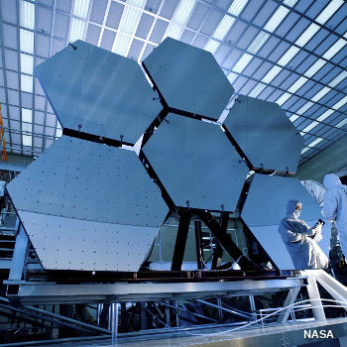
- Refraction:
  - Light waves travel in straight lines through empty space (a vacuum), but more interesting things happen to them when they travel through other materials—especially when they move from one material to another. That's not unusual: we do the same thing ourselves.
  - Have you noticed how your body slows down when you try to walk through water? You go racing down the beach at top speed but, as soon as you hit the sea, you slow right down. No matter how hard you try, you cannot run as quickly through water as through air. The dense liquid is harder to push out of the way, so it slows you down. Exactly the same thing happens to light if you shine it into water, glass, plastic or another more dense material: it slows down quite dramatically. This tends to make light waves bend—something we usually call refraction.
  - Refraction is amazingly useful. If you wear eyeglasses, you probably know that the lenses they contain are curved-shape pieces of glass or plastic that bend (refract) the light from the things you're looking at.
  - 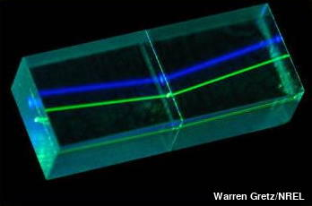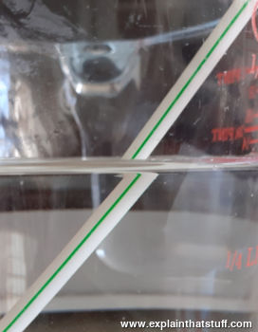
- Diffraction
  - We can hear sounds bending round doorways, but we can't see round corners—why is that? Like light, sound travels in the form of waves (they're very different kinds of waves, but the idea of energy traveling in a wave pattern is broadly the same). Sound waves tend to range in size from a few centimeters to a few meters, and they will spread out when they come to an opening that is roughly the same size as they are—something like a doorway, for example. If sound is rushing down a corridor in your general direction and there's a doorway opening onto the room where you're sitting, the sound waves will spread in through the doorway and travel to your ears.
  - The same thing does not happen with light. But light will spread out in an identical way if you shine it on a tiny opening that's of roughly similar size to its wavelength. You may have noticed this effect, which is called diffraction, if you screw your eyes up and look at a streetlight in the dark. As your eyes close, the light seems to spread out in strange stripes as it squeezes through the narrow gaps between your eyelids and eyelashes. The tighter you close your eyes, the more the light spreads (until it disappears when you close your eyes completely).
  - 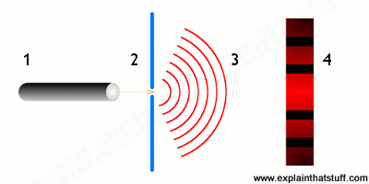
- Interference
  - If you stand above a calm pond (or a bath full of water) and dip your finger in (or allow a single drop to drip down to the water surface from a height), you'll see ripples of energy spreading outwards from the point of the impact. If you do this in two different places, the two sets of ripples will move toward one another, crash together, and form a new pattern of ripples called an interference pattern. Light behaves in exactly the same way. If two light sources produce waves of light that travel together and meet up, the waves will interfere with one another where they cross. In some places the crests of waves will reinforce and get bigger, but in other places the crest of one wave will meet the trough of another wave and the two will cancel out.
  - Photo: Thin-film interference makes the colors you see swirling around on the surface of soap bubbles.
  - 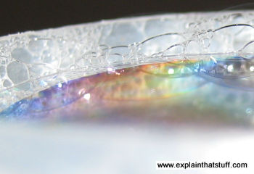
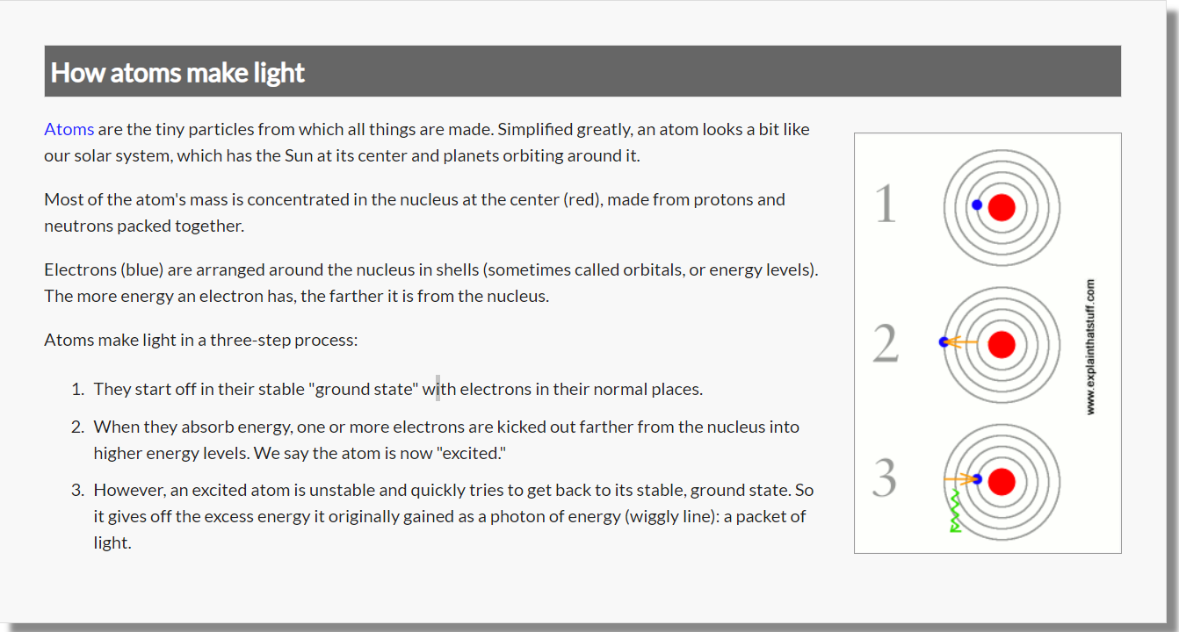
How Light Really Works?
Once you understand how atoms take in and give out energy, the science of light makes sense in a very interesting new way. Think about mirrors, for example. When you look at a mirror and see your face reflected, what's actually going on? Light (maybe from a window) is hitting your face and bouncing into the mirror. Inside the mirror, atoms of silver (or another very reflective metal) are catching the incoming light energy and becoming excited. That makes them unstable, so they throw out new photons of light that travel back out of the mirror towards you. In effect, the mirror is playing throw and catch with you using photons of light as the balls!
The same idea can help us explain things like photocopiers and solar panels (flat sheets of the chemical element silicon that turn sunlight into electricity). Have you ever wondered why solar panels look black even when they're in full sunlight? That's because they're reflecting back little or none of the light that falls on them and absorbing all the energy instead. (Things that are black absorb light, and reflect little or none, while things that are white reflect virtually all the light that falls on them, and absorb little or none. That's why it's best to wear white clothes on a scorching hot day.) Where does the energy go in a solar panel if it's not reflected? If you shine sunlight onto the solar cells in a solar panel, the atoms of silicon in the cells catch the energy from the sunlight. Then, instead of producing new photons, they produce a flow of electricity instead through what's known as the photoelectric (or photovoltaic) effect. In other words, the incoming solar energy (from the Sun) is converted to outgoing electricity.

JWST (James Webb Space Telescope):
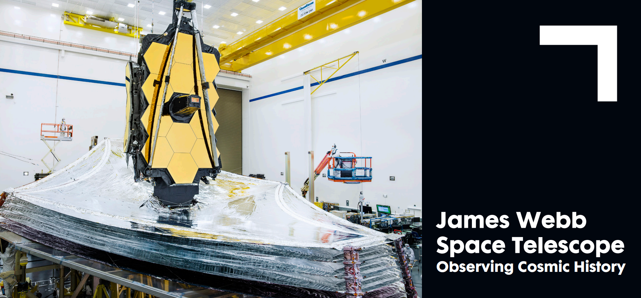
THE MISSION
NASA’s James Webb Space Telescope will examine every phase of cosmic history: from the first luminous objects after the Big Bang to the formation of galaxies, stars, and planets to the evolution of our own solar system. Peering over 13.5 billion years into the past when the first stars and galaxies were forming, Webb will capture images and spectra that will fundamentally alter our understanding of the universe. Webb will use its superb angular resolution and near-infrared instruments to study planetary systems similar to our own, analyze the molecular composition of extra-solar planets’ atmospheres, and directly image Jupiter-size planets orbiting nearby stars. By extending our knowledge of the cosmos, the James Webb Space Telescope will play an important role in our quest to answer compelling questions such as: “How did the universe begin?" or "When were the first stars and galaxies created?" or "How do planets form?" and "How do we fit in the cosmos?” Identified as NASA’s top science mission, Webb will enable the next generation of astrophysics discoveries and serve the international scientific community.
THE DESIGN
Webb is a one-of-a kind scientific instrument incorporating innovative design, advanced technology and groundbreaking engineering. To observe objects at distances billions of light years away, Webb’s primary mirror must be large enough to gather their dim light, and its optics and detectors must be cold enough to see their faint infrared emissions. The powerful observatory’s design features an aperture primary mirror that measure 21.4 feet (6.5 meter) in diameter, composed of 18 hexagonal segments. Together with the highly sensitive infrared detectors, this large mirror, which could fit seven Hubble Space Telescope mirrors within its surface area, gives the telescope the light-collecting ability to see objects hundreds of times fainter than those currently observed by ground and space based telescopes.
The five-layer sunshield, nearly the size of a tennis court, will shield the telescope from sunlight and allow it to passively cool to a frigid temperature of approximately 45 Kelvin (-380˚F; -228˚ Celsius). The extreme cold enables Webb to detect distant objects at infrared wavelengths. This infrared capability also permits Webb to detect light from newly forming stars and planets in our galaxy. These objects form within dense, dusty clouds that block visible light. To fit inside the Ariane 5 rocket fairing, the large primary mirror must be folded in sections for launch, then unfolded precisely into place after launch, making it the first segmented optical system deployed in space. Once in space, the sunshield will deploy to its full size and block light from the Earth, the Sun and Moon.
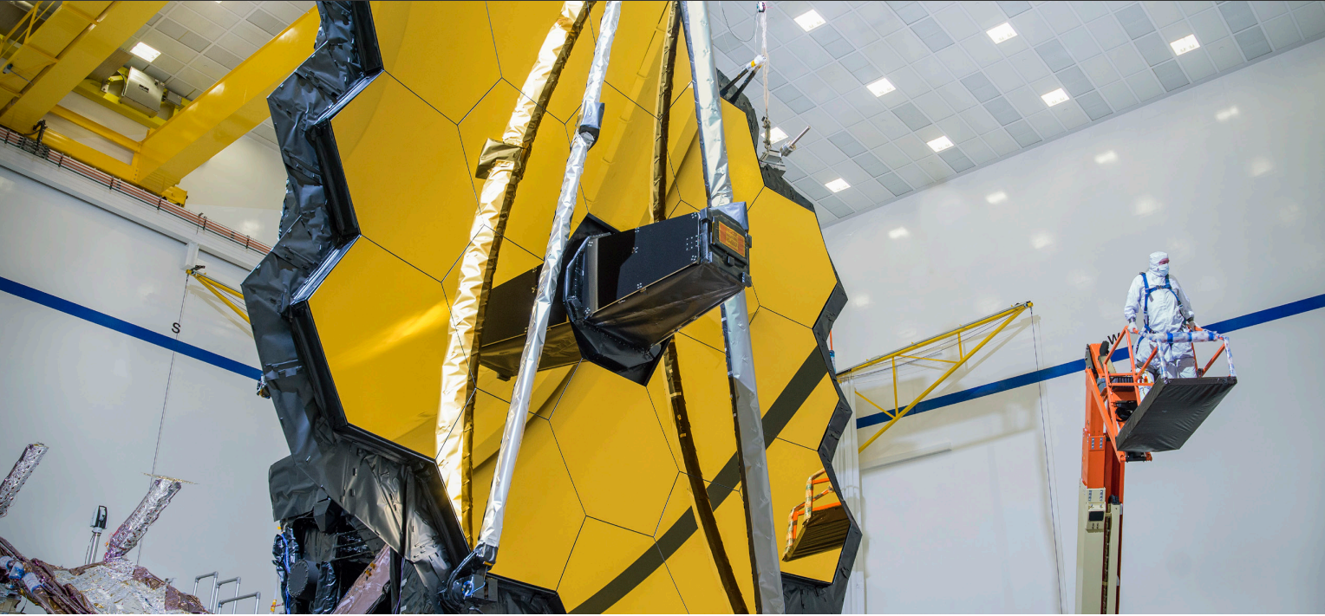
The Team
Northrop Grumman leads the industry team for NASA’s James Webb Space Telescope, the largest, most complex and powerful space telescope ever built. NASA leads an international partnership that includes the European Space Agency and the Canadian Space Agency. NASA’s Goddard Space Flight Center manages the Webb project, and the Space Telescope Science Institute is responsible for science and mission operations, as well as ground station development.
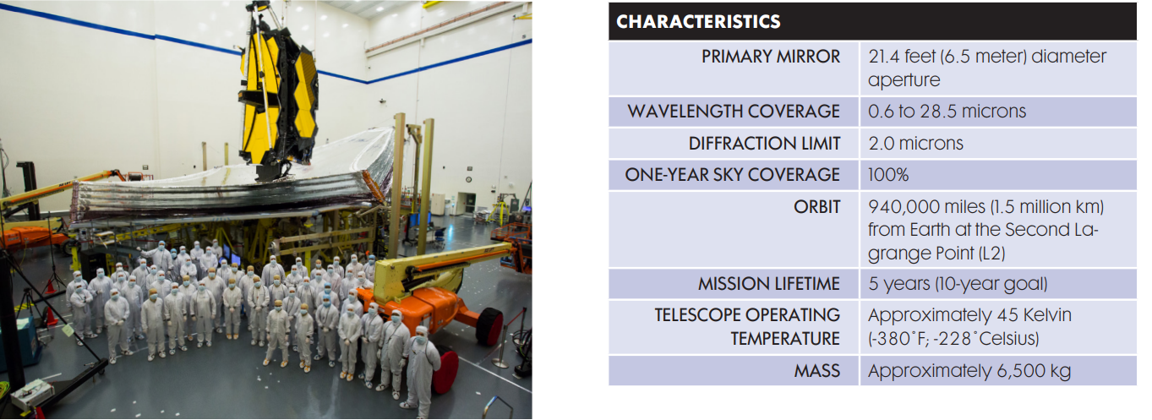
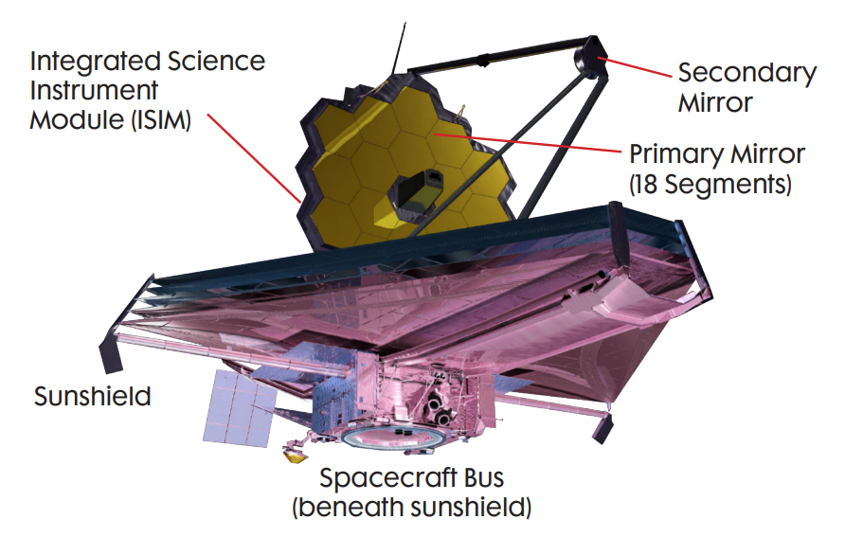
How the James Webb Space Telescope Will Unfold the Universe | John C. Mather | TED: https://www.youtube.com/watch?v=0BSaphO1v-U&ab_channel=TED

Harvesting Solar Power in Space and beaming to Earth with Lasers

Laser Development History at Northrop Grumman:
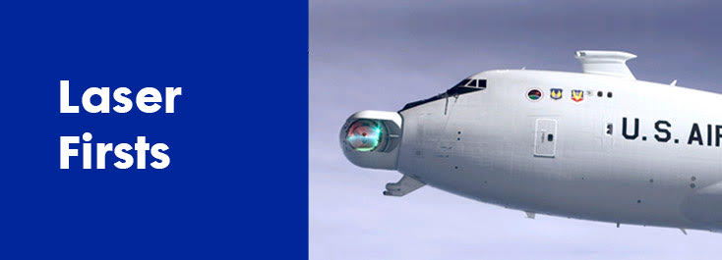
NORTHROP GRUMMAN LASER 'FIRSTS'

2011
-Maritime Laser Demonstrator completes at-sea tests by successfully conducting 'counter-material' demonstrations against small boat threats, becoming:
-First Navy laser system to go to sea, installed on a decommissioned Spruanceclass destroyer, for the program's culminating demonstration;
-First Navy laser system to be integrated with a ship's radar and navigation system; and
-First electric laser weapon to be fired at sea from a moving platform. Other tests of solid-state lasers for the Navy have been conducted from land-based positions.
2010
-First ballistic missile intercept by ALTB
-JHPSSL Phase 3 laser system becomes first solid-state laser chosen by U.S. Army for its Solid State Laser Testbed Experiment at the High Energy Laser Test Facility at White Sands Missile Range
-Maritime Laser Demonstrator
-First time a high-energy laser has been fired at-sea from a moving Navy platform against a static, land-based target
-First time a laser system has the lethal capability to perform to the required energy levels from a significant stand-off range
-First time a laser system tracked a small surface target in a sea state up to 3
2009
-JHPSSL exceeds 100kw power level, most powerful beam ever from a solid-state laser; sets run time record for a solid-state laser
-ABL (renamed Airborne Laser Test Bed) team completes long-duration firings of high-energy laser
2008
-ABL industry team demonstrates complete weapon system for first time by firing megawatt-class laser through precision beam steering system
-Northrop Grumman announces FIRESTRIKE, world's first weaponized solid-state laser for U.S. military services
-Joint High Power Solid State Laser (JHPSSL) sets new records for power, run time and beam quality, reaching 30 kilowatts
2007
-COIL achieves 1st light onboard Airborne Laser aircraft.
2006
-First industry facility dedicated to solid-state, high-energy laser systems production opens at Northrop Grumman's Space Park campus in Redondo Beach, Calif.
-Vesta debuts - a compact, solid-state laser with high-power, excellent beam quality and long run times for multiple military uses (from fixed-site protection to precision strike)
-Strategic Illuminator Laser (SILL) meets all technical performance requirements in tests that prove it's the highest power, brightest continuously pulsed laser of its kind ever built. Funded by the Missile Defense Agency, SILL is a new, diode-pumped, solid-state, next-generation pulsed illuminator laser.
2005
-Joint High Power Solid State Laser (JHPSSL) demonstrator blasts one of the most powerful (more than 27kW), continuously operating (350 seconds), solid-state laser beams ever produced by an electric laser - believed to be the brightest beam ever produced by this technology.

2004
-Missile Defense Agency successfully fires Northrop Grumman-built Chemical Oxygen Iodine Laser, the first megawatt-class laser built for an airborne environment for ABL
-THEL Testbed shoots down mortars - singles and a salvo proving that directed energy can be applied on the battlefield to address current threats
-THEL Testbed destroys a large-caliber rocket carrying a live warhead in-flight - the largest, fastest and highest flying target ever destroyed by a high-energy laser
2003
-Northrop Grumman selected to develop the Strategic Illuminator Laser (SILL) for the Missile Defense Agency (MDA), providing a crucial component for systems such as ABL and future space-based programs.
-Delivery of the brightest flight-qualified kilowatt-class solid state laser - the Beacon Illuminator Laser built for ABL
2002
-First in-flight destruction of an artillery projectile (THEL). By 2004, THEL had recorded 46 successful shoot downs including 28 Katyusha rockets; 5 artillery projectiles; 3 large-caliber rockets; and 10 mortars
2001
-First COIL laser module packaged for flight operations built for the Airborne Laser (ABL)
2000
-First in-flight destruction of salvoed short-range, live artillery rockets (THEL)
1999
-Record output power for mid-IR solid state laser (DARPA/Tri-Service Mid IR II Laser)
1996
-First in-flight destruction of short-range artillery rocket (Nautilus)
1995
-World-record chemical oxygen iodine laser (COIL) efficiencies
1992
-Record brightness for solid state laser in near-infrared
1991
-First megawatt-class laser engineered for space operations (Alpha)
1980
-First megawatt-class chemical laser (MIRACL)
1978
-First shoot down of missile in flight by laser (Navy ARPA Chemical Laser)
1973
-First high energy (>100 kW) chemical laser (Baseline Demonstration Laser)
1970
-High energy laser research begins at Northrop Grumman

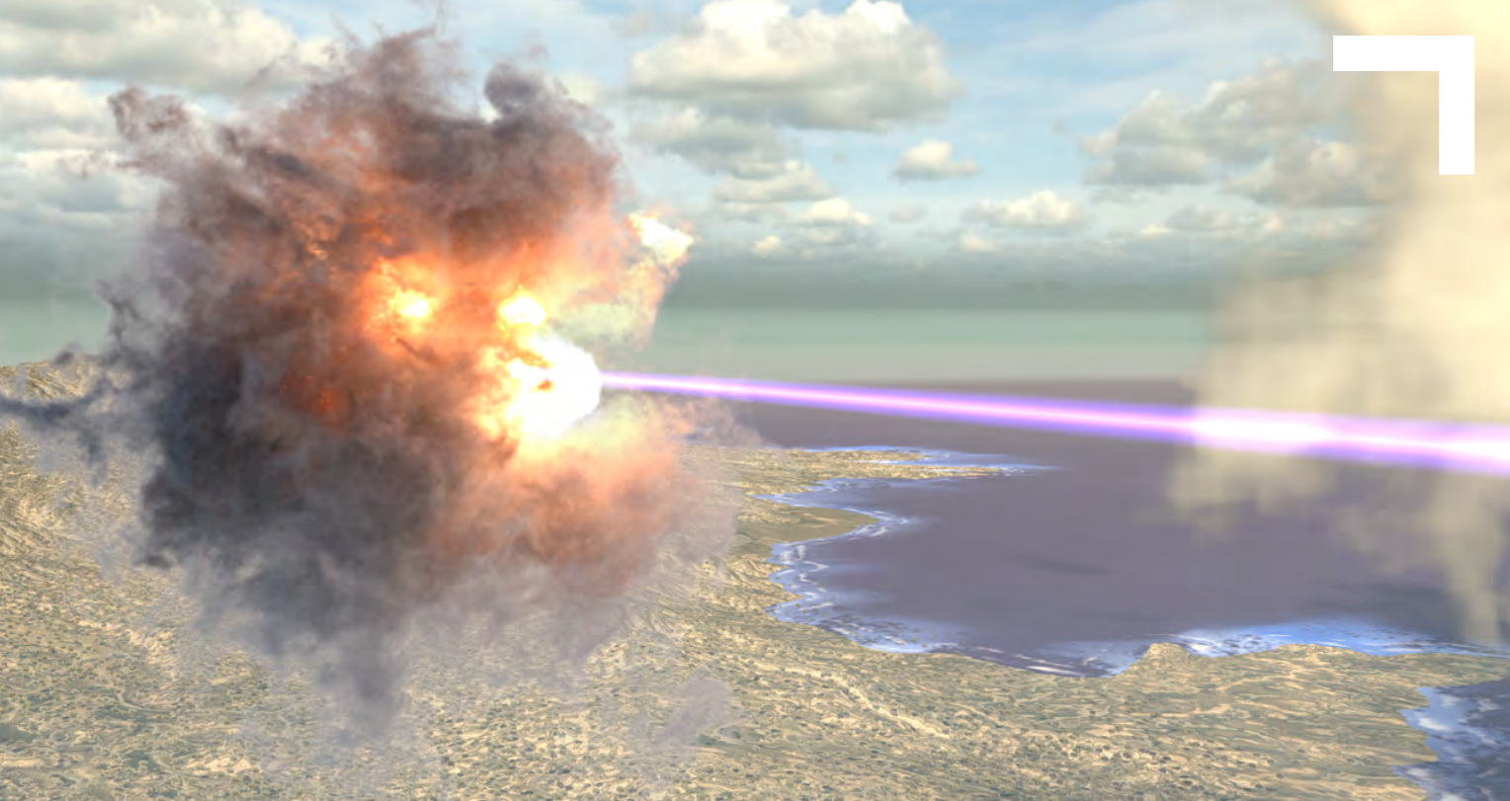
Directed Energy
For the last 50 years, we’ve advanced laser technology to defend against current and future threats. Our innovations include:
- Advanced targeting and tracking using machine learning
- Modularized architectures
- Scalable subsystems
- Low size, weight, power and cost
- Rugged components and materials
- Miniaturized systems with high-power output
Northrop Grumman develops high-energy laser solutions to defend our nation at sea, on land, and in the air. Our technology is protecting U.S. forces from a range of threats, such as unmanned aerial systems, rockets, artillery and mortars, fast attack boats and missiles.

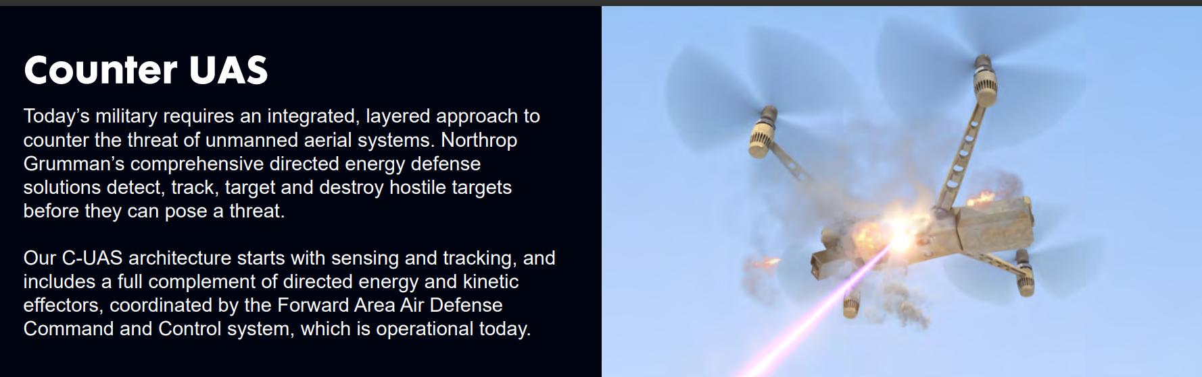
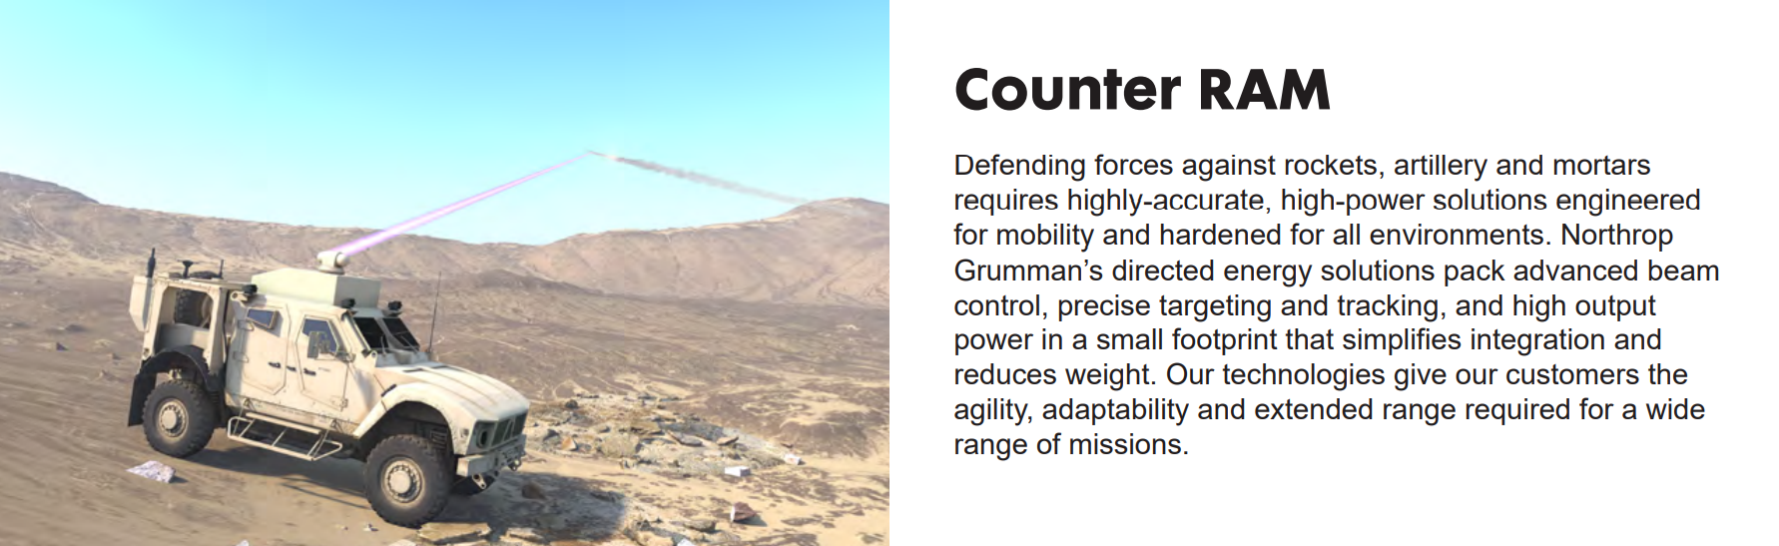
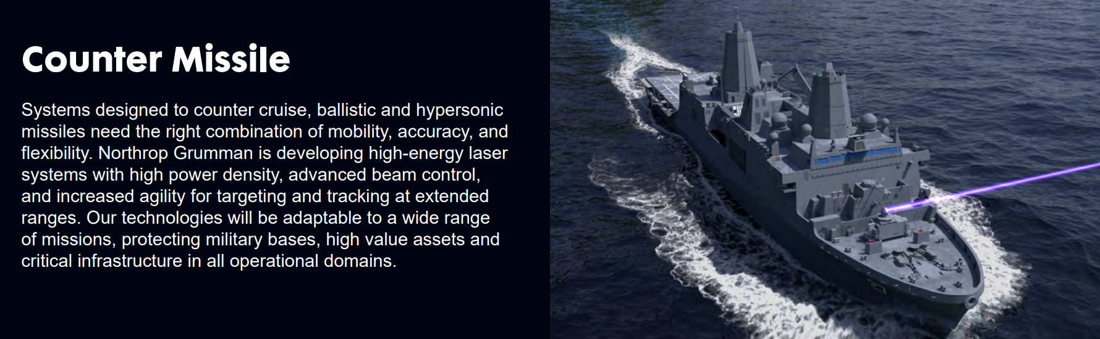
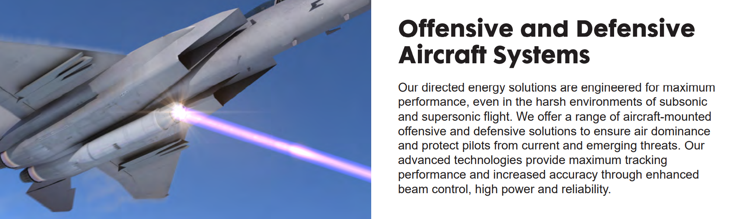

Light and Power in the Gospel of Jesus Christ
The Power of Light and Truth, Elder Robert R. Steuer: https://www.churchofjesuschrist.org/study/general-conference/2008/04/the-power-of-light-and-truth?lang=eng
How do we obtain this spiritual light and ensure that the truths of the Gospel fill our soul?
- First learn true doctrine
- Gain pure testimony
- Live courageously in accordance with the light and testimony that we have received
“In 1832 the Lord revealed to the Prophet Joseph Smith a true and powerful doctrine about spiritual light, the Light of Christ: ‘Which light proceedeth forth from the presence of God to fill the immensity of space – The light which is in all things, which giveth life to all things, which is the laws by which all things are governed, even the power of God who sitteth upon his throne’”
“Recent scientific thinking on the fundamental properties of light is indeed stunning. Today scientist even describe light as a ‘carrier’ or ‘messenger’ or ‘mediator’.”
Results of light and power in our life: (from Look unto Jesus Christ, Elder Kim B. Clark): https://www.churchofjesuschrist.org/study/general-conference/2019/04/33clark?lang=eng
- We can see! Through revelation.
- We can bless the children of God, guide, protect, strengthen, and heal others through priesthood power
- Jesus goes with us where we go. When we teach, comfort, bless, he is there.

Christ: The Light That Shines in Darkness, Sharon Eubank - https://www.churchofjesuschrist.org/study/general-conference/2019/04/42eubank?lang=eng
Things that can dim the light in our lives:
- Some of Us Are Paralyzed with Grief
- Some of Us Are Just So Tired
- Some of Us Feel We Don’t Fit the Traditional Mold
- Some of Us Are Splintering with Questions
- Some of Us Feel We Can Never Be Good Enough

Elder Bednar - patterns of light -
- Part 1: The Light of Christ: https://www.churchofjesuschrist.org/media/video/2012-01-0010-patterns-of-light-the-light-of-christ
  - Light = Radiant - a brilliance and a sense of direction from light.
  - Light chases darkness; darkness, cannot overtake light
  - Associated with light is a warmth, associated with darkness is a coolness
  - What is the Light of Christ?
    - Many would call a conscious. Natural desire to help someone in distress. Influence from God to be good and do good.
    - If we yield to that light it increases, if we disobey light decreases and can be diminished.
- Part 2: Discerning Light - https://www.churchofjesuschrist.org/media/video/2012-01-0011-patterns-of-light-discerning-light?lang=eng
  - Sometimes we question is it inspiration or my own thoughts?
  - We have to act to find out the source. Is it the power of God?
  - That which invites/entices us to do good and be good comes from God.
  - Anyone can be influenced by the Holy Ghost, but the Gift of the Holy Ghost invites inspiration from heaven.
- Part 3: Spirit of Revelation - https://www.churchofjesuschrist.org/media/video/2012-01-0012-patterns-of-light-spirit-of-revelation?lang=eng
  - Revelation is communication from God to his children on the earth
  - Sometimes dramatic like a light switch in a dark room. (more rare than common)
  - Light comes gradually like the rising of the sun. You can discern the increase of light on the horizon, but never all at once. (pattern is more common than rare).
  - Sometimes like a foggy day. Enough light to tell it is not dark, but not well lit. Can take a few steps, but can’t see more, but the light continues to help us see.
  - Jesus Christ is the Light of the world, a light that is endless, that can never be darkened.
  - One of Jesus’ names is “the Light”. If we follow his teaching there is illumination in our life.
  - “I know when there is a power beyond my own that comes from God to me, through me which is the spirit of revelation”. Elder Bednar

Doctrines and Covenants 50:24 - That which is of God is light; and he that receiveth light, and continueth in God, receiveth more light; and that light groweth brighter and brighter until the perfect day.

