Fracture Detection Using Seismic Attributes

GDC has many clients with fault dominated reservoirs. Therefore, GDC has joined with some hydrocarbon exploration companies to help fund development of seismic processing technologies which allow detection of the magnitude, orientation, and trends of fracture systems using 3-D seismic surveys. In the beginning of 2006, this work is at the stage of moving from being a research project to being production seismic processing. This note illustrates research results and summarizes capabilities available to clients.

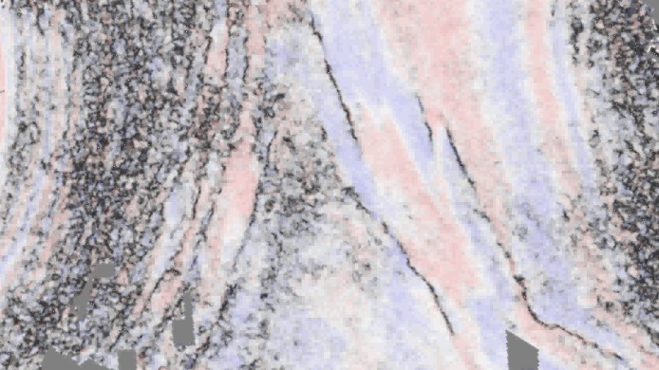
Figure 1. Faults trends derived from a 3-D seismic volume.

VOLUMETRIC CURVATURE

One of the techniques available to GDC customers is called Volumetric Curvature. This process involves volumetric estimates of reflector curvature, which estimates are computed on a 3D seismic volume (typically a migrated stack or offset-limited stacks) and do not require picking of individual horizons. Output is a volume with computed curvature values. Curvature attributes provide insight into the structural setting and the stress regime. This technique is convenient to integrate production data for calibration and to provide quantitative estimates of fracture direction and intensity

Motivation: Structural Geology models relate curvature to fractures

Will the fractures observed on an image log in one well be consistent in direction and intensity with the amount of fracturing predicted by the volumetric curvature technique?

Will the intersection of curvature (change in dip) trends directly correlated with the better performing wells?

This curvature analysis is based on the principal that stresses applied to an area will result in predictable orientations of fractures, folds, and faults related to the orientation of the three principal stresses:

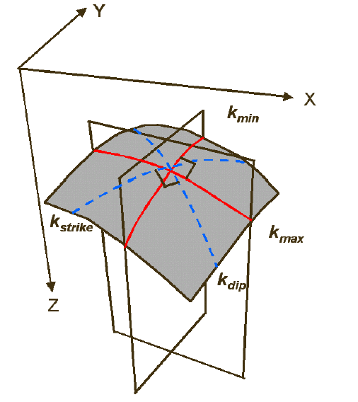

Figure 2. Curvature in 3 dimensions, showing maximum curvature Kmax, minimum
curvature Kmin, dip curvature Kdip and strike curvature Kstrike.

Volumetric curvature analysis is a simple but computationally intensive procedure that provides insight into fracture orientation and regional stresses. Volumetric curvature is best estimated in a two-step process. In the first step, GDC uses a moving analysis cube to estimate volumetric reflection dip and azimuth which represents the best single dip for each sample in the full volume. In the second step, GDC calculates curvature from adjacent measures of dip and azimuth. GDC uses larger curvature analysis windows to estimate longer wavelength curvatures. This technique allows us to output full 3-D volumes of curvature values at one or more scales of analysis.

Until recently, curvature has been limited to computation along horizon surfaces that may be affected by unintentional bias and picking errors introduced during the interpretation process. This new technique avoids the interpreter bias problem by calculating curvature at every point in the seismic volume. Such volumetric curvature calculations are also amenable to 3-D visualization including animation, opacity analysis, and voxel picking.

The problem of robustness is addressed through the use of a multi-window estimation of dip and azimuth that is based on a finite temporal window rather than the single sample peak or trough estimates used in map analysis. The dip and azimuth results from the analysis are output as inline and crossline dip for each sample in the volume.

Finally, the curvature at each sample is calculated at various wavelengths using a fractional derivative of the dip vector.

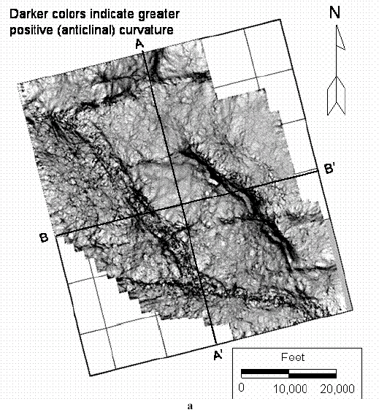
Figure 3. Example of volumetric curvature analysis.

The example demonstrates the potential of this new technology to determine stress regimes and predict azimuths of open fracture systems at any time or stratigraphic position within a 3-D cube. This provides a new and rapid method of seismically analyzing fractured reservoirs.

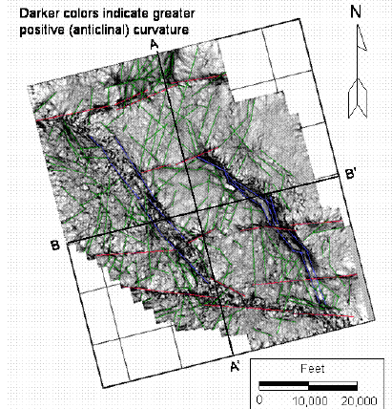
Figure 4. Red and Blue lineaments represent coherency type fault trends, while the green lineaments are only visible after using volumetric curvature analysis.

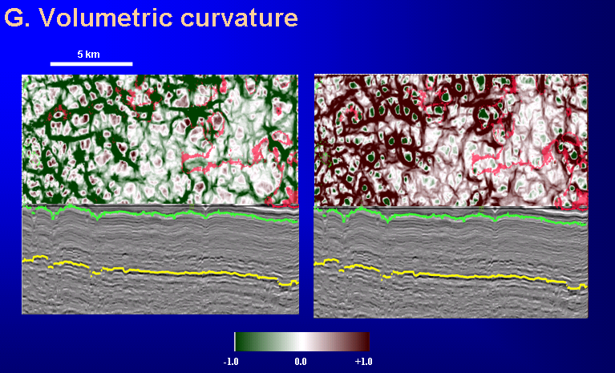
Figure 5. Volumetric curvature analysis results from a carbonate 3-D seismic survey.

