Hurricane Mesa Petrified Wood
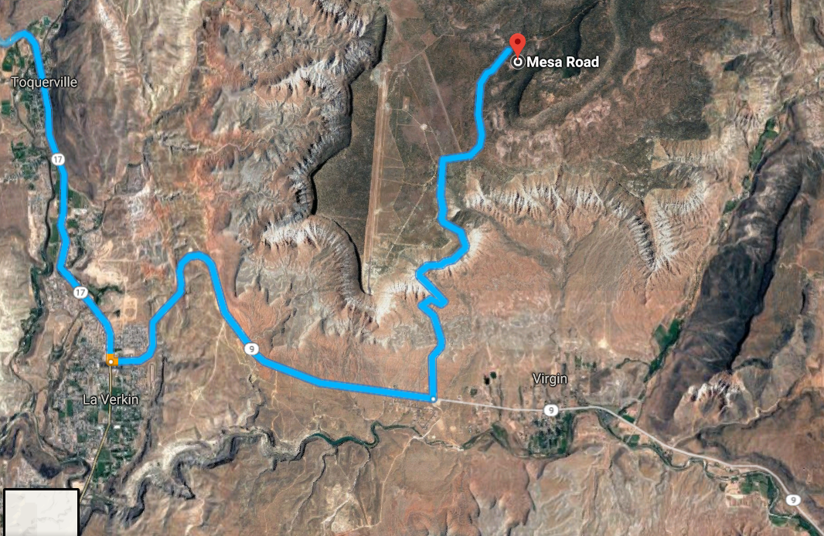
This link is directions to the Hurricane Mesa Petrified Wood. These rocks are found in the Triassic Chinle Formation (237-247 million years old), which is the same formation as the Petrified Forest National Park in Arizona and the Escalante Petrified Forest State Park in Utah. Petrified wood is formed when trees are buried and protected from decay due to oxygen and organisms. Then, as the sediments are buried and put under pressure and temperature at depth, the groundwater, which is rich in dissolved solids flows through the sediment, replacing the original tree fibers with silica.
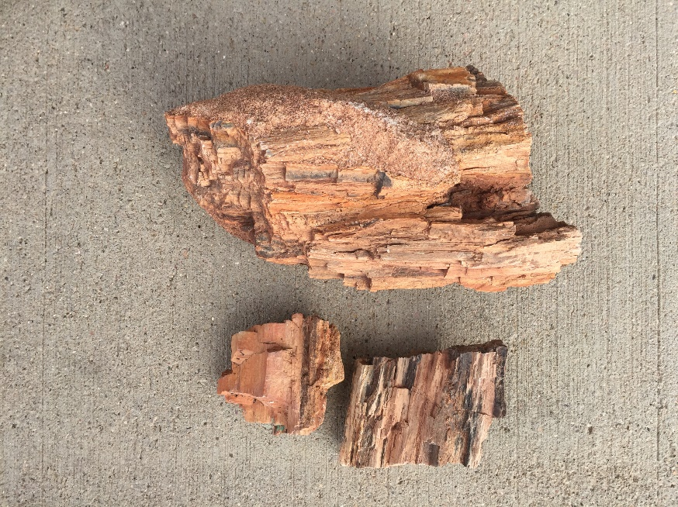
Dugway Geodes
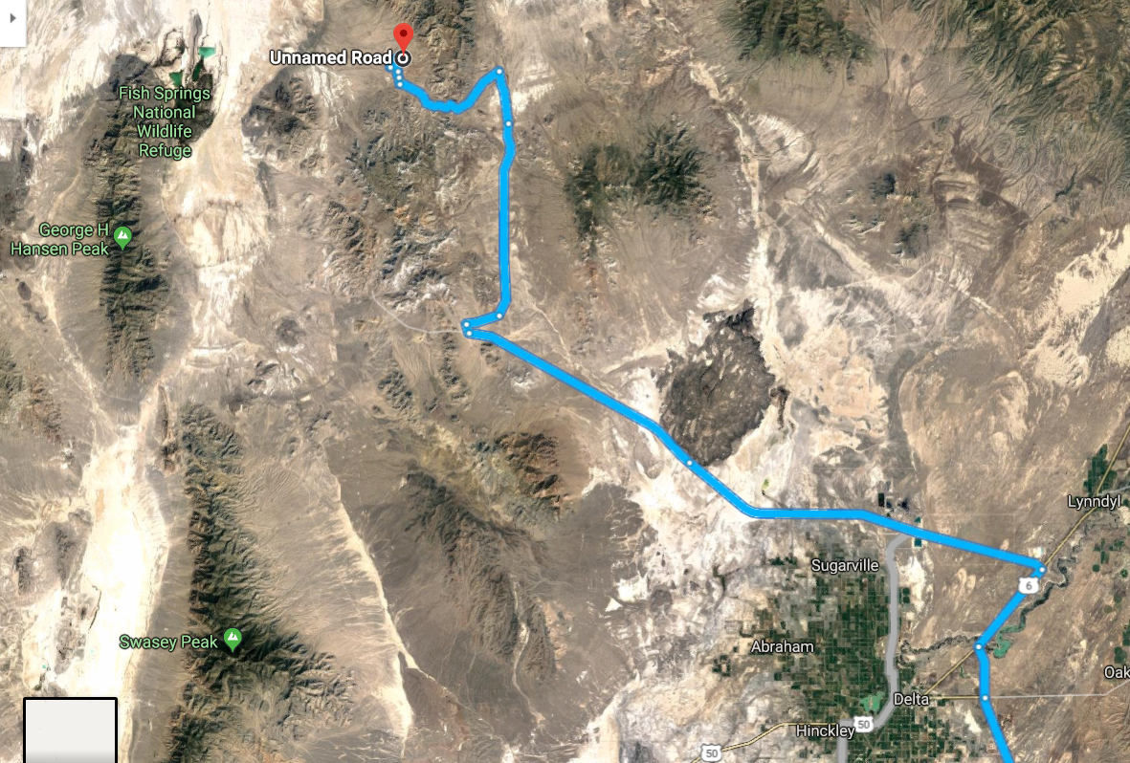
This link is directions to the Dugway Geodes. These rocks are from Miocene extrusive igneous rocks (6-23 million years ago) called rhyolite. Trapped gasses formed cavities within the rhyolite, and millions of years of ground-water circulation allowed minerals to precipitate into the cavities creating spherical shaped geodes with crystal-lined cavities. Lake Bonneville, 32,000 to 14,000 years ago, eroded the geode-bearing rhyolite and redeposited the geodes several miles away as lake sediments.
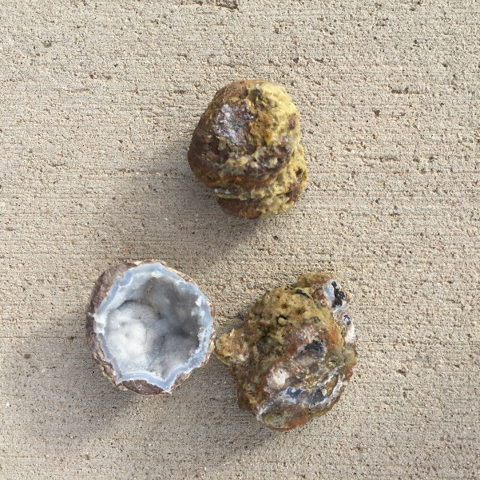
Glitter Pit Selenite Crystals
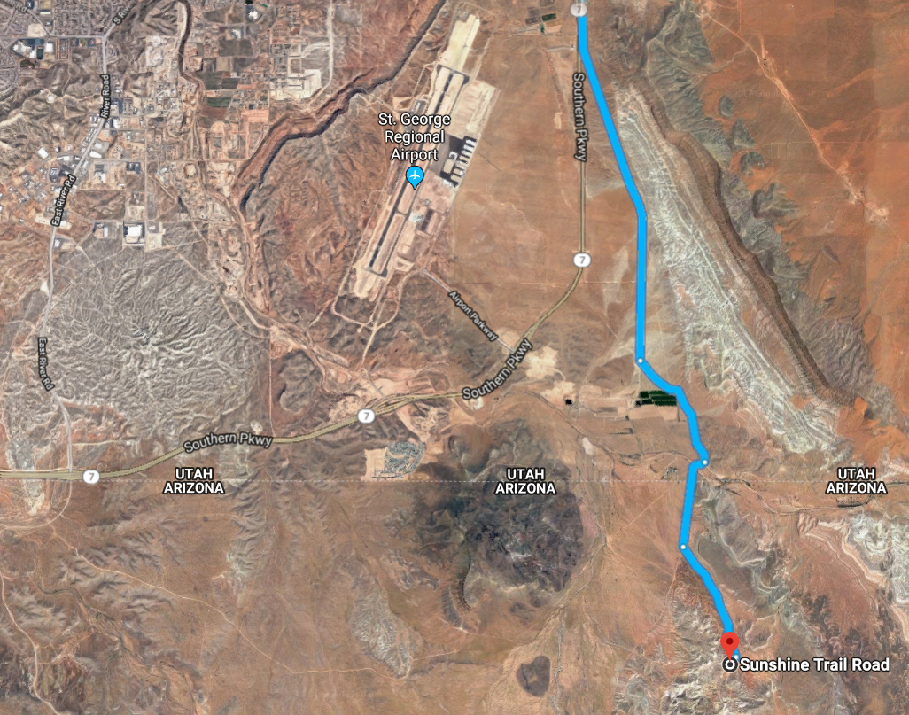
This link is directions to the Glitter Pit. These rocks are Permian (254-299 million year old) gypsum crystals, a type of calcite known as selenite. Calcite is common in sedimentary rocks, particularly in limestone, which is formed from the shells of dead marine organisms. There are similar selenite crystals outside of Gillette, Wyoming. There are volcanic flows both in Gillette and in the St. George area. Gypsum is typically an evaporite, formed when large lacustrine lakes deposited sediments and then evaporated, like at the Great Salt Lake salt flats. I anticipate these crystals were formed when volcanic activity (probably when the major faults in the Basin & Range were formed in the Miocene about 15 million years ago) increased the temperature and melted the gypsum, and then it slowly cooled. This volcanic activity could have been within the last
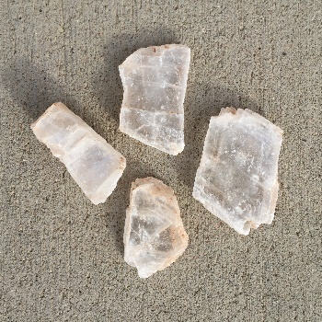
Table Butte Chalcedony
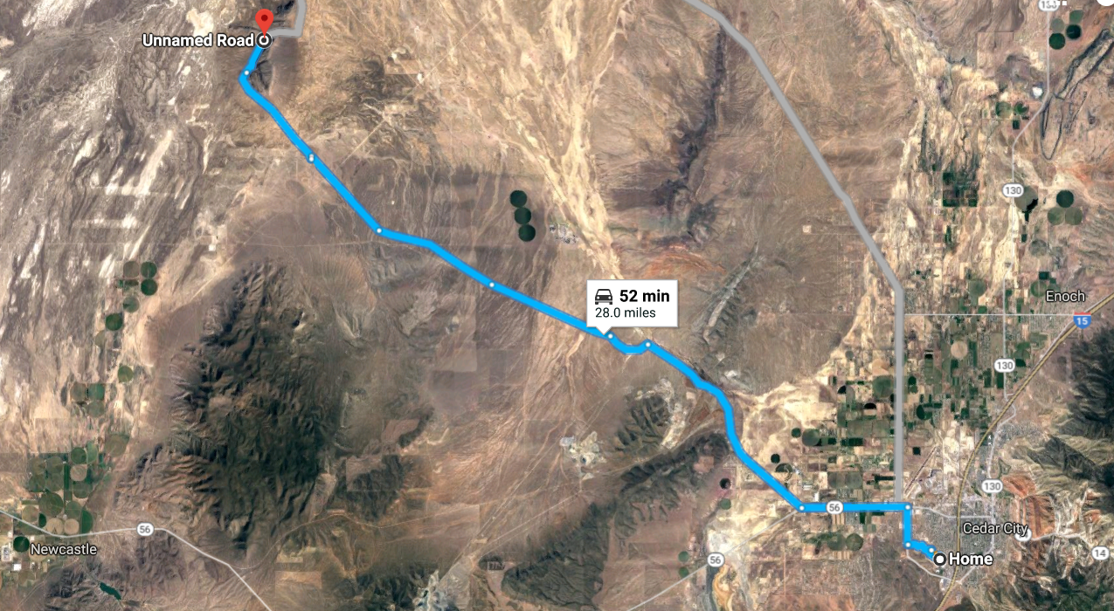
This link is directions to the Table Butte chalcedony. Table Butte is largely made up of volcanic rhyolites (probably Miocene, or about 15 million years old), and the chalcedony formed in cavities left by gases that came up with the rhyolite. This is very similar to the Dugway Geodes, only the rocks at Table Butte Mountain did not form into spheres. There are star shaped chalcedony structures where the cavities within the rhyolites were formed.
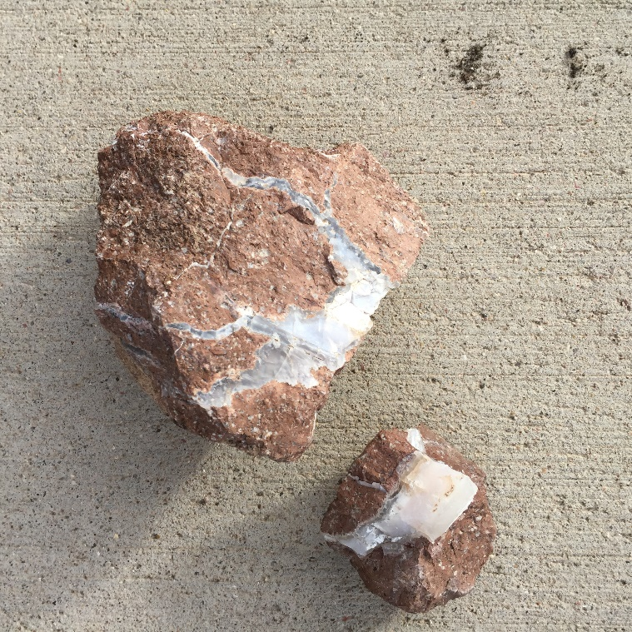
Enoch Pidgeon Blood Agate
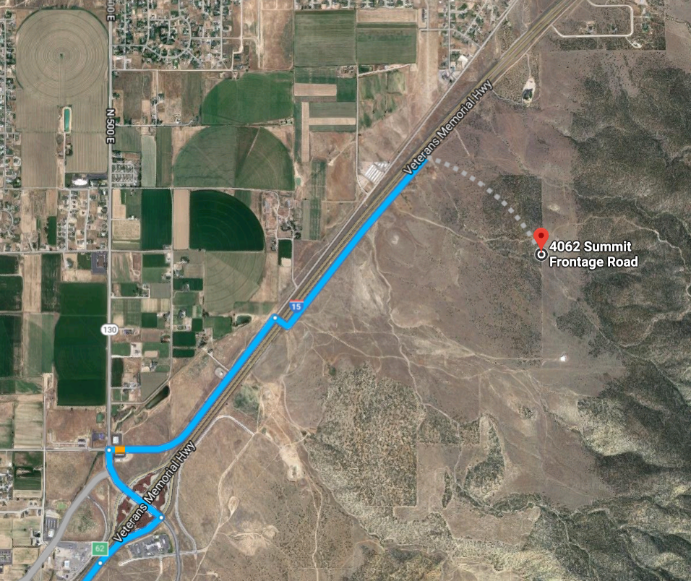
This link is directions to the Enoch Pidgeon Blood Agate. Agates are a form of chalcedony, or silicon dioxide in the form of microscopic fibrous quartz crystals. Agates develop inside host rocks as layers are filled molecule-by-molecule, layer-by-layer, as these microcrystals self-organize to form concentric bands and other patterns. There are very unique blue agates in the Fiddler’s Canyon area, and Pidgeon Blood red agates form a little to the north of Fiddler’s, as shown in the map above. These agates are probably Miocene in age (about 15 million years old), related to the volcanics accompanying the formation of the Basin & Range Province. The color is a function of mineral impurities. The red is hematite from iron ore. At one time the word chalcedony was reserved for light blue translucent material. Agate was reserved for limestone deposited stones in the White Cliffs of Dover. Agate and Jasper are both a form of chalcedony.
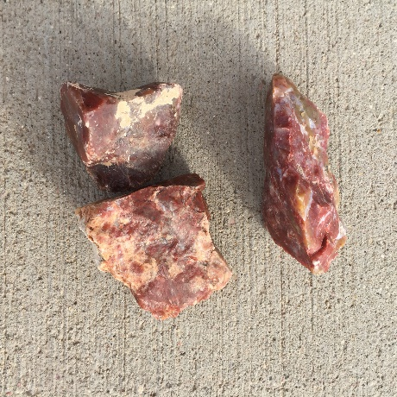
Orderville Septarian Nodules
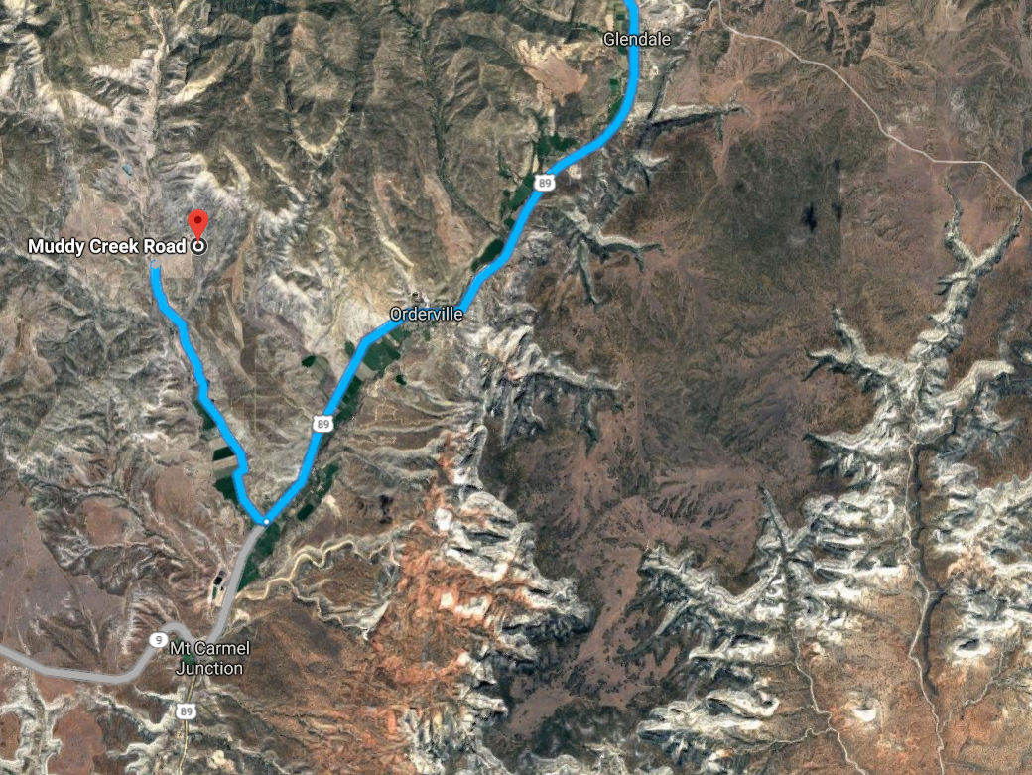
This link is directions to the Orderville Septarian Nodules (Cretaceous age, 50-70 million years old), when the Gulf of Mexico reached to what is now Southern Utah. Septarians possibly formed as a result of volcanic eruptions, when dead sea life was chemically attracted to sediments around them, forming mud balls or concretions. As the oceans receded, the balls dried and cracked. Calcite crystals form in the cracks. The mud balls are basically a gray bentonite (clay), with a thin brown layer of aragonite separating the calcite and bentonite. Sometimes here are barite crystals or fossils poking out of the calcite crystals. The organic origins of rocks is shown by the fact many of them fluoresce under a black light.
